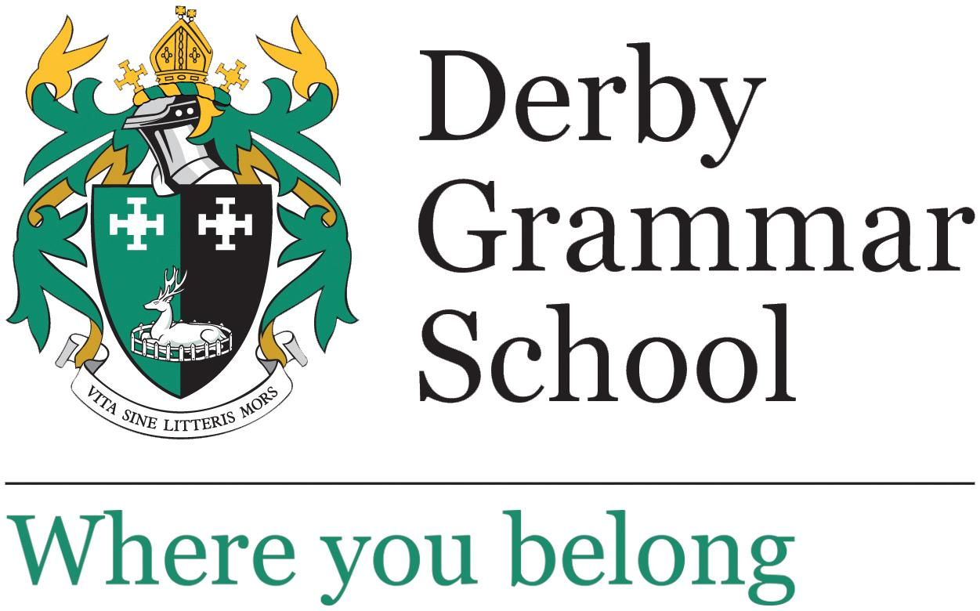

Key Stage 2 Teacher

Permanent

Full time

Start: September 2025

Suitable for ECTs: Yes

Salary: Derby Grammar School pay scale

Closing date: Monday 21 April 2025 at 4pm

This is an exciting opportunity to join our Primary School as a Teacher of Key Stage 2. At Derby Grammar School, we understand that children develop at different rates and have designed an inclusive curriculum which looks to encourage independence, resilience and interpersonal skills. Our hands-on approach to teaching means that children receive stimulating and awe-inspiring experiences that create a love of learning.

The successful candidate will be an excellent classroom teacher with the ability to inspire and challenge all pupils to achieve their full potential. Flexibility and confidence in working with our mixed year group classes is essential, as is energy and enthusiasm for the ethos of our family orientated school. We teach many subjects in mixed year group classes, benefiting from specialist teaching in some subject areas, and we teach the core subjects of English, Mathematics, Science and PSHE in single year group classes.

Derby Grammar School is a coeducational all-through school from Reception to Sixth Form. We enjoy positive and constructive working relationships with our students and parents.